RESTAURANT FOOD DELIVERY ANALYSIS REPORT

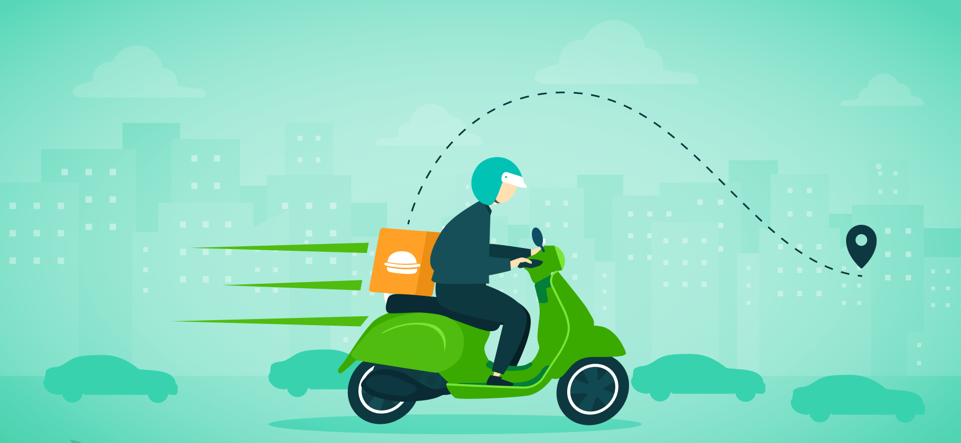

INTRODUCTION
Anthony Robbins once said, “Once you have mastered time, you will understand how true it is that most people overestimate what they can accomplish in a year – and underestimate what they can achieve in a decade! ” People want to create enough time in 24 hours to accomplish the tasks they set for themselves. Therefore, they look for ways to minimise the time they spend on any task. An instance is in getting food from a restaurant. The time it takes one from preparing to leave his base to getting food from a restaurant and finishing a meal can be shortened by ordering the food from the restaurant and using the wait time to accomplish other tasks.
This project aims to derive insights into the food delivery business, its successes, and challenges. The data is sourced from https://fp20analytics.com/datasets/, with data cleaning and preparation in Power Query and analysis in Power BI.

OBJECTIVE
The objective of this project is to:
- Measure the delivery performance
- Analyse the revenue and profitability
- Analyse the drivers’ efficiency
- Understand customer ordering behaviour

DATA DESCRIPTION
The dataset contains the following features:
- Date: The date the order was placed
- Time customer placed order
- Time order placed at restaurant
- Time driver arrived at restaurant
- Delivery time: The time the customer got the order delivered
- Driver ID: Unique identifier of the driver
- Driver name
- Restaurant ID: Unique ID of the restaurant
- Customer ID: Unique ID of the customer
- Delivery area: The area where the customer received the order
- ASAP: Boolean for fast track delivery
- Sub Total: fee for the food delivered
- Delivery fee: fee for the logistics
- Service fee: fee for the service platform
- Discount
- Tip: tip given to the driver
- Refunded amount: amount refunded to the customer

DATA CLEANING AND PREPARATION
The data was imported into Power Query, and the following steps were taken to clean and prepare the data for analysis:
- The datatype of the time columns was corrected from datetime to time.
- The values of the columns were checked for errors and wrong syntax. There was none observed.
- A new column was created for the time of day of the order placed (morning, afternoon, and night).
- The table was duplicated, and a dimension table was created for the driver (driver ID and driver name), and duplicates were removed.
- In the fact table, the driver name column was removed.
- Empty cells in each column were removed.

DATA MODELLING & DAX CALCULATIONS
Moving into the Power BI interface, the first thing done under data modelling was creating a dimension date table using DAX. This was done using the formula below.
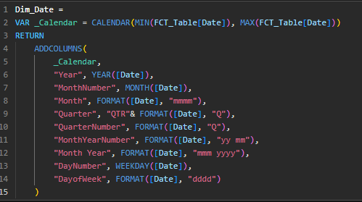
The next step was to turn off the auto time intelligence in the settings and mark the above table as the date table.
Furthermore, a one-to-many relationship was created between the dimension tables and the fact table.
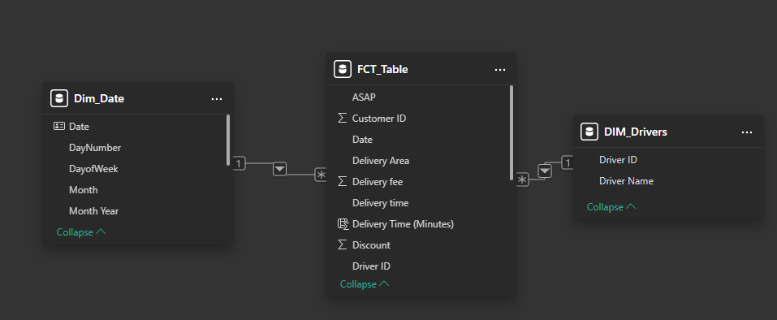
A new column was created to get the total delivery time using the formula below.
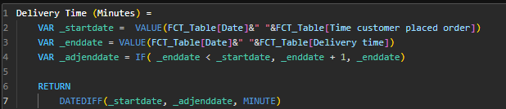
The following DAX formulas were created for the analysis:
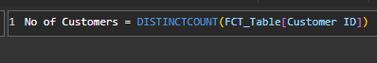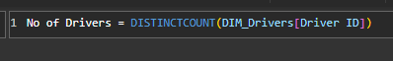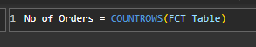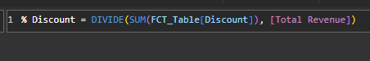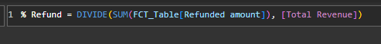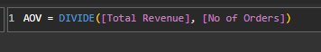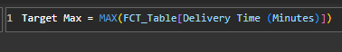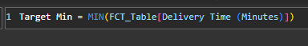
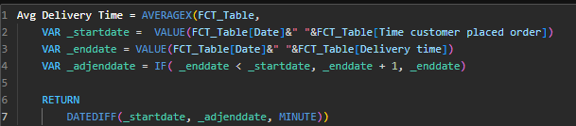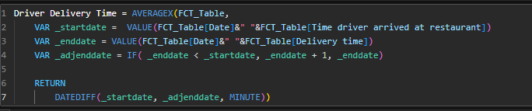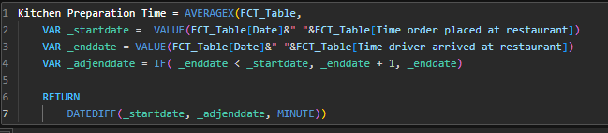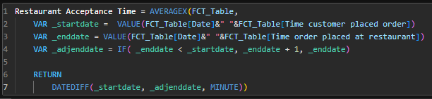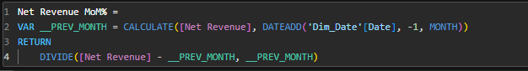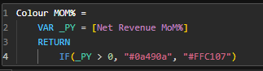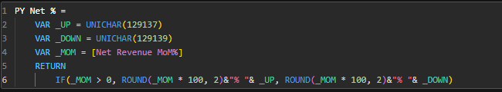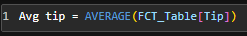

DATA ANALYSIS
The following are the questions asked for each objective.
- The revenue and profitability analysis
- What is the revenue generated by the delivery area?
- Does express delivery affect the revenue?
- What is the trend of total/net revenue over time?
- What is the trend of average order value (AOV) over time?
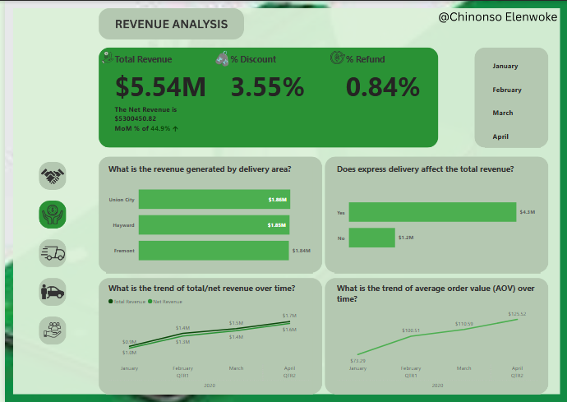
- The delivery performance
- How does the delivery time vary by location?
- How does the delivery time vary by express service?
- What is the on-time delivery rate?
- How does the delivery time vary by the time of day?
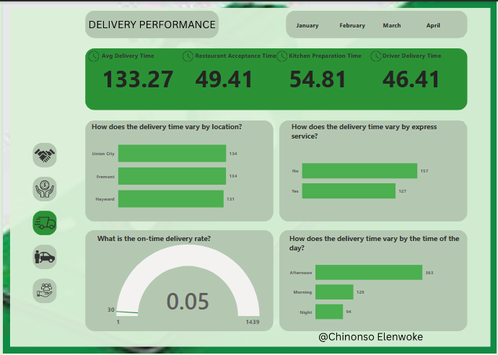
- The drivers’ performance
- Who are the top drivers with the most deliveries?
- Who are the best drivers with the least average delivery time?
- What is the trend of deliveries by drivers over time?
- Who are the top drivers with the most average tips?
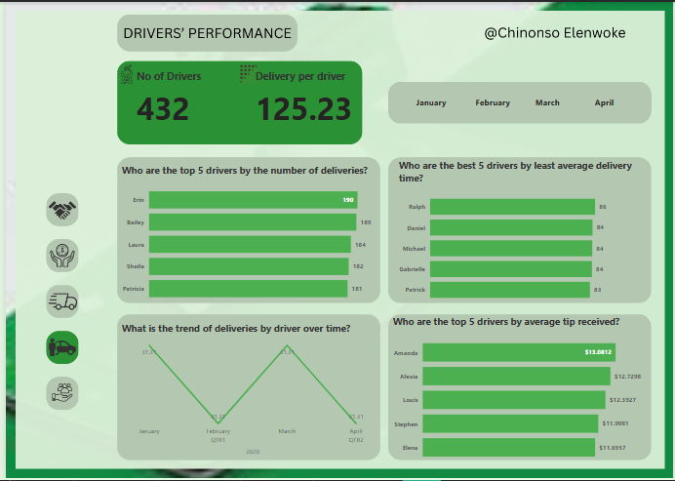
- The customer behaviour analysis
- Which customers made the most orders?
- What is the trend of customer order frequency?
- Which time of day had peak orders?
- Which day of the week had peak orders?
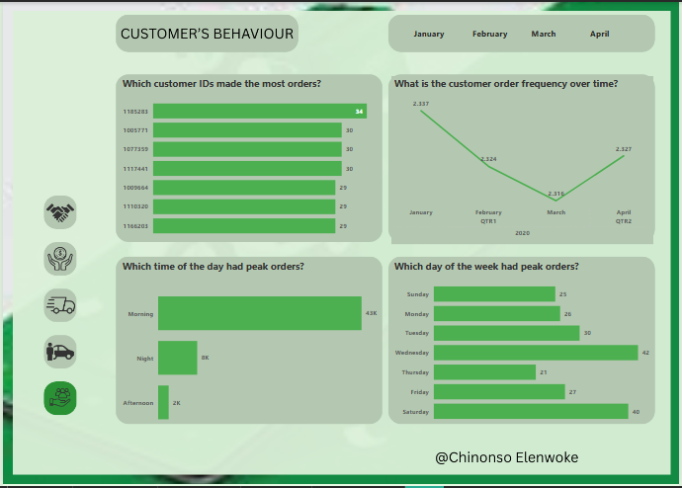

RECOMMENDATION
- The discount strategy should be revised based on certain criteria, like the customer segment. The customer segment should be based on the order frequency and average order value.
- Optimise the driver’s assignment algorithm to reduce the delivery time. Things like the proximity to the restaurant and the customer’s destination, historical performance with the restaurant, and current traffic patterns should be considered in the driver’s assignment.
- Implement win-back campaigns for customers with declining order frequency.

